**What is natural language processing?**

Natural language processing (NLP) refers to the branch of computer science—and more specifically, the branch of [artificial intelligence or AI](https://www.ibm.com/topics/artificial-intelligence)—concerned with giving computers the ability to understand text and spoken words in much the same way human beings can.

NLP combines computational linguistics—rule-based modelling of human language—with statistical, machine learning, and deep learning models. Together, these technologies enable computers to process human language in the form of text or voice data and to ‘understand’ its full meaning, complete with the speaker or writer’s intent and sentiment.

NLP drives computer programs that translate text from one language to another, respond to spoken commands, and summarize large volumes of text rapidly—even in real time. There’s a good chance you’ve interacted with NLP in the form of voice-operated GPS systems, digital assistants, speech-to-text dictation software, customer service chatbots, and other consumer conveniences. But NLP also plays a growing role in enterprise solutions that help streamline business operations, increase employee productivity, and simplify mission-critical business processes.

NLP tasks

Human language is filled with ambiguities that make it incredibly difficult to write software that accurately determines the intended meaning of text or voice data. Homonyms, homophones, sarcasm, idioms, metaphors, grammar and usage exceptions, variations in sentence structure—these just a few of the irregularities of human language that take humans years to learn, but that programmers must teach natural language-driven applications to recognize and understand accurately from the start, if those applications are going to be useful.

Several NLP tasks break down human text and voice data in ways that help the computer make sense of what it's ingesting. Some of these tasks include the following:

* **Speech recognition**, also called speech-to-text, is the task of reliably converting voice data into text data. Speech recognition is required for any application that follows voice commands or answers spoken questions. What makes speech recognition especially challenging is the way people talk—quickly, slurring words together, with varying emphasis and intonation, in different accents, and often using incorrect grammar.
* **Part of speech tagging**, also called grammatical tagging, is the process of determining the part of speech of a particular word or piece of text based on its use and context. Part of speech identifies ‘make’ as a verb in ‘I can make a paper plane,’ and as a noun in ‘What make of car do you own?’
* **Word sense disambiguation** is the selection of the meaning of a word with multiple meanings through a process of semantic analysis that determine the word that makes the most sense in the given context. For example, word sense disambiguation helps distinguish the meaning of the verb 'make' in ‘make the grade’ (achieve) vs. ‘make a bet’ (place).
* **Named entity recognition,**or NEM, identifies words or phrases as useful entities. NEM identifies ‘Kentucky’ as a location or ‘Fred’ as a man's name.
* **Co-reference resolution** is the task of identifying if and when two words refer to the same entity. The most common example is determining the person or object to which a certain pronoun refers (e.g., ‘she’ = ‘Mary’),  but it can also involve identifying a metaphor or an idiom in the text  (e.g., an instance in which 'bear' isn't an animal but a large hairy person).
* **Sentiment analysis**attempts to extract subjective qualities—attitudes, emotions, sarcasm, confusion, suspicion—from text.
* **Natural language generation**is sometimes described as the opposite of speech recognition or speech-to-text; it's the task of putting structured information into human language.

**NLP tools and approaches**

Python and the Natural Language Toolkit (NLTK)

The Python programing language provides a wide range of tools and libraries for attacking specific NLP tasks. Many of these are found in the Natural Language Toolkit, or NLTK, an open source collection of libraries, programs, and education resources for building NLP programs.

The NLTK includes libraries for many of the NLP tasks listed above, plus libraries for subtasks, such as sentence parsing, word segmentation, stemming and lemmatization (methods of trimming words down to their roots), and tokenization (for breaking phrases, sentences, paragraphs and passages into tokens that help the computer better understand the text). It also includes libraries for implementing capabilities such as semantic reasoning, the ability to reach logical conclusions based on facts extracted from text.

**Statistical NLP, machine learning, and deep learning**

The earliest NLP applications were hand-coded, rules-based systems that could perform certain NLP tasks, but couldn't easily scale to accommodate a seemingly endless stream of exceptions or the increasing volumes of text and voice data.

Enter statistical NLP, which combines computer algorithms with machine learning and [deep learning](https://www.ibm.com/in-en/topics/deep-learning) models to automatically extract, classify, and label elements of text and voice data and then assign a statistical likelihood to each possible meaning of those elements. Today, deep learning models and learning techniques based on convolutional neural networks (CNNs) and recurrent neural networks (RNNs) enable NLP systems that 'learn' as they work and extract ever more accurate meaning from huge volumes of raw, unstructured, and unlabeled text and voice data sets.

**NLP use cases**

Natural language processing is the driving force behind machine intelligence in many modern real-world applications. Here are a few examples:

* **Spam detection:**You may not think of spam detection as an NLP solution, but the best spam detection technologies use NLP's text classification capabilities to scan emails for language that often indicates spam or phishing. These indicators can include overuse of financial terms, characteristic bad grammar, threatening language, inappropriate urgency, misspelled company names, and more. Spam detection is one of a handful of NLP problems that experts consider 'mostly solved' (although you may argue that this doesn’t match your email experience).
* **Machine translation:**Google Translate is an example of widely available NLP technology at work. Truly useful machine translation involves more than replacing words in one language with words of another.  Effective translation has to capture accurately the meaning and tone of the input language and translate it to text with the same meaning and desired impact in the output language. Machine translation tools are making good progress in terms of accuracy. A great way to test any machine translation tool is to translate text to one language and then back to the original. An oft-cited classic example: Not long ago, translating “The spirit is willing but the flesh is weak” from English to Russian and back yielded “The vodka is good but the meat is rotten.” Today, the result is “The spirit desires, but the flesh is weak,” which isn’t perfect, but inspires much more confidence in the English-to-Russian translation.
* **Virtual agents and chatbots:** [Virtual agents](https://www.ibm.com/in-en/products/watson-assistant) such as Apple's Siri and Amazon's Alexa use speech recognition to recognize patterns in voice commands and natural language generation to respond with appropriate action or helpful comments. [Chatbots](https://www.ibm.com/in-en/topics/chatbots) perform the same magic in response to typed text entries. The best of these also learn to recognize contextual clues about human requests and use them to provide even better responses or options over time. The next enhancement for these applications is question answering, the ability to respond to our questions—anticipated or not—with relevant and helpful answers in their own words.
* **Social media sentiment analysis:**NLP has become an essential business tool for uncovering hidden data insights from social media channels. Sentiment analysis can analyze language used in social media posts, responses, reviews, and more to extract attitudes and emotions in response to products, promotions, and events–information companies can use in product designs, advertising campaigns, and more.
* **Text summarization:**Text summarization uses NLP techniques to digest huge volumes of digital text and create summaries and synopses for indexes, research databases, or busy readers who don't have time to read full text. The best text summarization applications use semantic reasoning and natural language generation (NLG) to add useful context and conclusions to summaries.

**What is Syntactic analysis?**

Syntactic analysis is defined as analysis that tells us the logical meaning of certainly given sentences or parts of those sentences. We also need to consider rules of grammar in order to define the logical meaning as well as the correctness of the sentences.

Or, In simple words, Syntactic analysis is the process of analysing natural language with the rules of formal grammar. We applied grammatical rules only to categories and groups of words, not applies to individual words.

The syntactic analysis basically assigns a semantic structure to text. It is also known as syntax analysis or parsing. The word ‘parsing’ is originated from the Latin word ‘pars’ which means ‘part’. The syntactic analysis deals with the syntax of Natural Language. In syntactic analysis, grammar rules have been used.

Let’s take an example to gain more understanding:

Consider the following sentence:

**Sentence: School go a boy**

The above sentence does not logically convey its meaning, and its grammatical structure is not correct. So, Syntactic analysis tells us whether a particular sentence conveys its logical meaning or not and whether its grammatical structure is correct or not.

As we discussed the steps or different levels of NLP, the third level of NLP is Syntactic analysis or parsing or syntax analysis. The main aim of this level is to draw exact meaning, or in simple words, you can say finding a dictionary meaning from the text. Syntax analysis checks the text for meaningfulness compared to the rules of formal grammar.

For Example, consider the following sentence

**Sentence: “hot ice cream”**

The above sentence would be rejected by the semantic analyser.

Now, let’s define the Syntactic analysis formally, In the above sense, syntactic analysis or parsing may be defined as the process of analysing the strings of symbols in natural language conforming to the rules of formal grammar.

Syntactic analysis is required to examine the relationship between the words in a sentence and the grammatical structure of a sentence in order to derive the true meaning of the sentence.

You could refer to syntactic analysis as the process of analyzing the strings of symbols in natural language in conformance with grammatical rules.

There are many elements of sentences that lexical analysis ignores, which syntactic analysis accounts for. For example, lexical analysis ignores stop words, which could change the entire meaning of a sentence. Lexical analysis does not even bother with identifying the parts-of-speech of the words from a sentence that is being analyzed.

Syntactic analysis also pays attention to the order of the words in a sentence, another aspect that is completely ignored by lexical analysis. It also considers the [morphology](https://en.wikipedia.org/wiki/Morphology_(linguistics)) of the words in the sentence, which lexical analysis simply cannot account for.

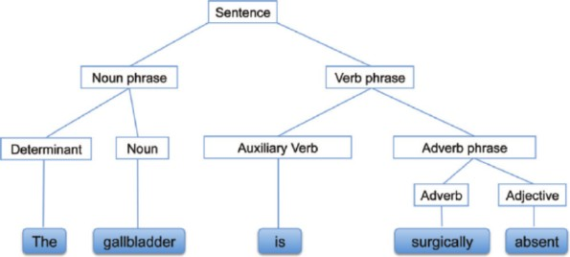

**What is a Parser?**

The parser is used to implement the task of parsing.

It is defined as the software component that is designed for taking input text data and gives a structural representation of the input after verifying for correct syntax with the help of formal grammar. It also generates a data structure generally in the form of a parse tree or abstract syntax tree or other hierarchical structure.

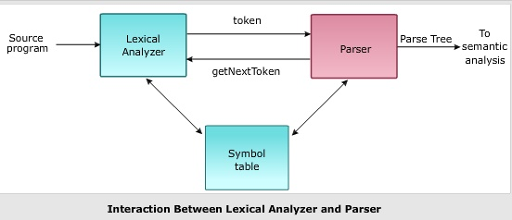

We can understand the relevance of parsing in NLP with the help of the following points:

* The parser can be used to report any syntax error.
* It helps to recover from commonly occurring errors so that the processing of the remainder of the program can be continued.
* A parse tree is created with the help of a parser.
* The parser is used to create a symbol table, which plays an important role in NLP.
* A parser is also used to produce intermediate representations (IR).

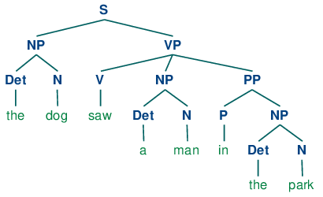

**Amazon Polly**

Amazon Polly uses deep learning technologies to synthesize natural-sounding human speech, so you can convert articles to speech. With dozens of lifelike voices across a broad set of languages, use Amazon Polly to build speech-activated applications.

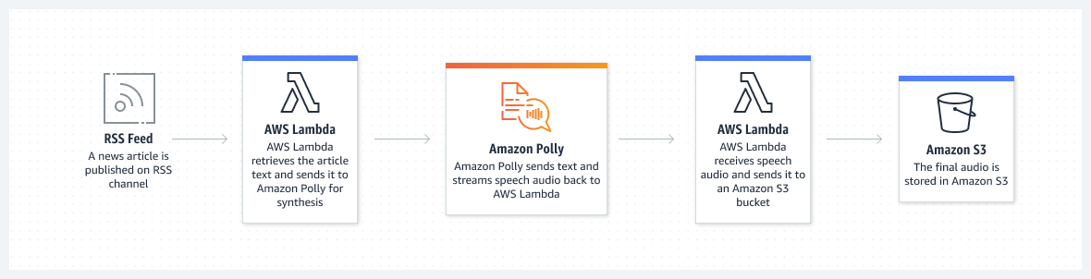

**How Amazon Polly Works**

Amazon Polly converts input text into life-like speech. You call one of the speech synthesis methods, provide the text that you want to synthesize, choose one of the Neural Text-to-Speech (NTTS) or Standard Text-to-Speech (TTS) voices, and specify an audio output format. Amazon Polly then synthesizes the provided text into a high-quality speech audio stream.

* Input text – Provide the text that you want to synthesize, and Amazon Polly returns an audio stream. You can provide the input as plain text or in Speech Synthesis Markup Language (SSML) format. With SSML you can control various aspects of speech, such as pronunciation, volume, pitch, and speech rate.
* Available voices – Amazon Polly provides a portfolio of languages and a variety of voices, including a bilingual voice (for both English and Hindi). For most languages you can choose from several voices, both male and female. When launching a speech synthesis task, you specify the voice ID, and then Amazon Polly uses this voice to convert the text to speech. Amazon Polly is not a translation service—the synthesized speech is in the same language as the text. However, if the text is in a different language than designated for the voice, numbers represented as digits (for example, *53*, not *fifty-three*) are synthesized in the language of the voice and not the text.
* Output format – Amazon Polly can deliver the synthesized speech in multiple formats. You can select the audio format that suits your needs. For example, you might request the speech in the MP3 or Ogg Vorbis format for consumption by web and mobile applications. Or you might request the PCM output format for consumption by AWS IoT devices and telephony solutions.

**What is Amazon Comprehend?**

* Amazon Comprehend uses natural language processing (NLP) to extract insights about the content of documents. It develops insights by recognizing the entities, key phrases, language, sentiments, and other common elements in a document. Use Amazon Comprehend to create new products based on understanding the structure of documents. For example, using Amazon Comprehend you can search social networking feeds for mentions of products or scan an entire document repository for key phrases.
* You can access Amazon Comprehend document analysis capabilities using the Amazon Comprehend console or using the Amazon Comprehend APIs. You can run real-time analysis for small workloads or you can start asynchronous analysis jobs for large document sets. You can use the pre-trained models that Amazon Comprehend provides, or you can train your own custom models for classification and entity recognition.
* Amazon Comprehend may store your content to continuously improve the quality of its pre-trained models.
* All of the Amazon Comprehend features accept UTF-8 text documents as the input. In addition, custom classification and custom entity recognition accept image files, PDF files, and Word files as input.
* Amazon Comprehend can examine and analyze documents in a variety of languages, depending on the specific feature. For more information, see [Languages supported in Amazon Comprehend](https://docs.aws.amazon.com/comprehend/latest/dg/supported-languages.html). Amazon Comprehend's [Dominant language](https://docs.aws.amazon.com/comprehend/latest/dg/how-languages.html) capability can examine documents and determine the dominant language for a far wider selection of languages.

**Amazon Comprehend insights**

Amazon Comprehend uses a pre-trained model to examine and analyze a document or set of documents to gather insights about it. This model is continuously trained on a large body of text so that there is no need for you to provide training data.

Amazon Comprehend analyzes the following types of insights:

* **Entities** – References to the names of people, places, items, and locations contained in a document.
* **Key phrases** – Phrases that appear in a document. For example, a document about a basketball game might return the names of the teams, the name of the venue, and the final score.
* **Personally Identifiable Information (PII)** – Personal data that can identify an individual, such as an address, bank account number, or phone number.
* **Language** – The dominant language of a document.
* **Sentiment** – The dominant sentiment of a document, which can be positive, neutral, negative, or mixed.
* **Targeted sentiment** – The sentiments associated with specific entities in a document. The sentiment for each entity occurrence can be positive, negative, neutral or mixed.
* **Syntax** – The parts of speech for each word in the document.

**Amazon Comprehend Custom**

You can customize Amazon Comprehend for your specific requirements without the skillset required to build machine learning-based NLP solutions. Using automatic machine learning, or AutoML, Amazon Comprehend Custom builds customized NLP models on your behalf, using data you already have.

**Custom classification** – Create custom classification models (classifiers) to organize your documents into your own categories.

**Custom entity recognition** – Create custom entity recognition models (recognizers) that can analyze text for your specific terms and noun-based phrases.

**How it works**

Amazon Comprehend uses a pre-trained model to gather **insights** about a document or a set of documents. This model is continuously trained on a large body of text so that there is no need for you to provide training data.

You can use Amazon Comprehend to build your own **custom models** for custom classification and custom entity recognition.

Amazon Comprehend provides **topic modeling** using a built-in model. Topic modeling examines a corpus of documents and organizes the documents based on similar keywords within them.

Amazon Comprehend provides synchronous and asynchronous **document processing modes**. Use synchronous mode for processing one document or a batch of up to 25 documents. Use an asynchronous job to process a large number of documents.

Amazon Comprehend works with AWS Key Management Service (AWS KMS) to provide enhanced encryption for your data.

**Amazon Translate**

Amazon Translate is a neural machine translation service that delivers fast, high-quality, affordable, and customizable language translation.

Amazon Translate lets you localize content for diverse global users and translate and analyze large volumes of text to activate cross-lingual communication between users.

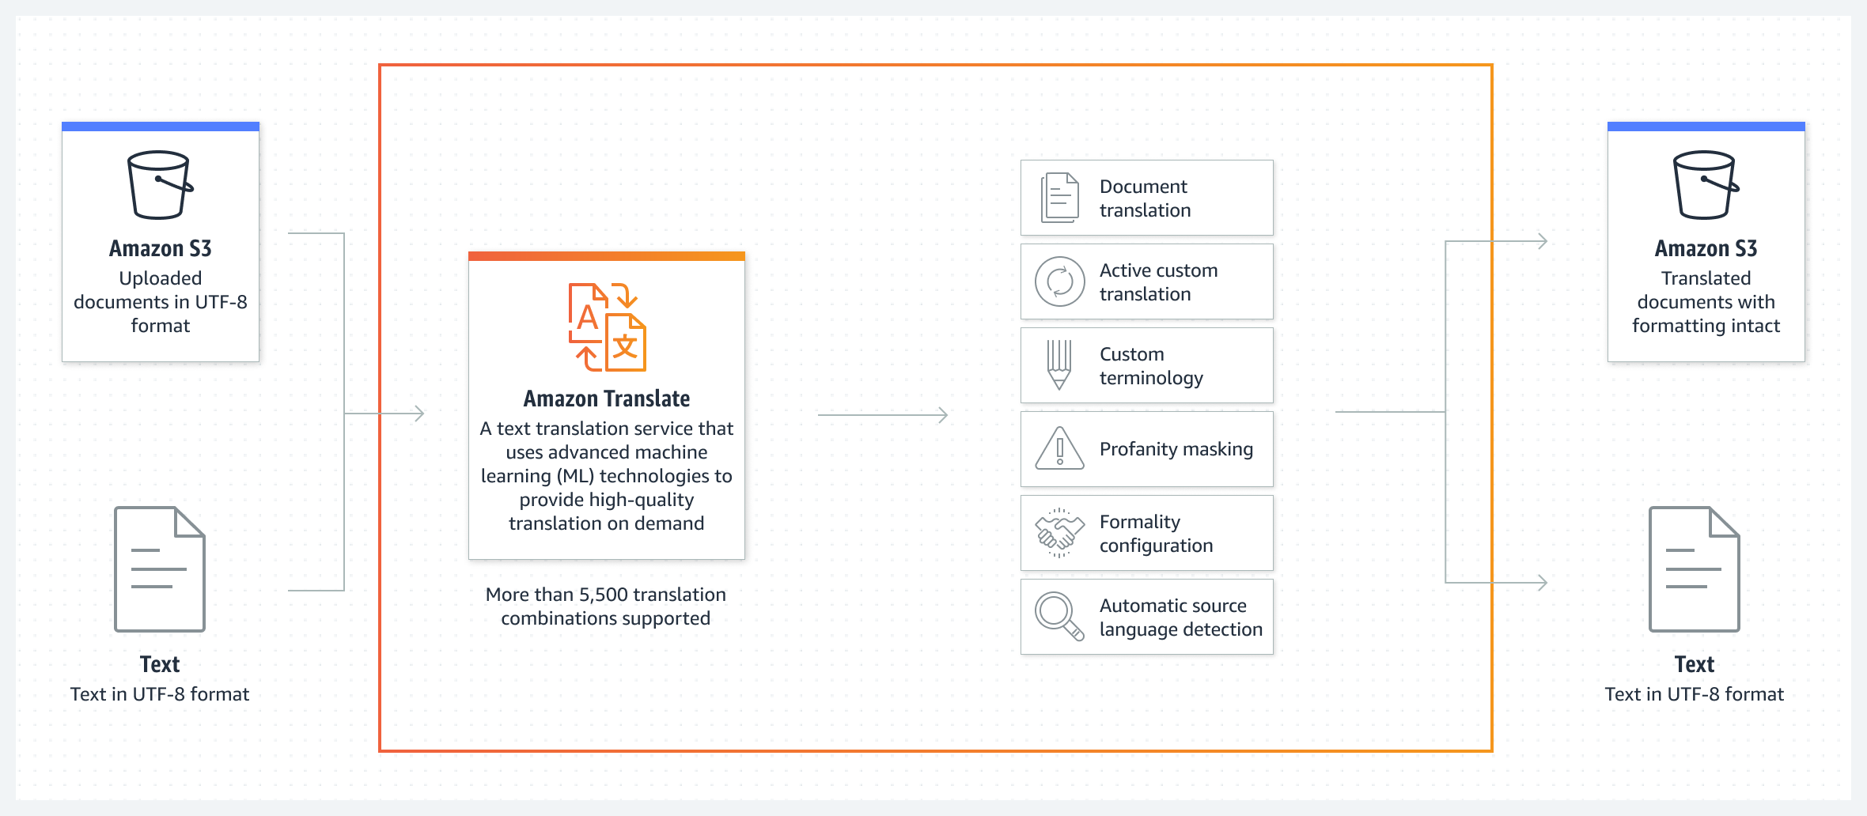

Amazon Translate delivers fast, high-quality, affordable, and customizable language translation. This is a neural machine translation service, which is a form of language translation automation that uses deep learning models to deliver more accurate and more natural sounding translation than traditional statistical and rule-based translation algorithms. The engines are trained on a wide variety of content across different use cases and domains to perform well on many kinds of content.

## **Key Features**

### Broad Language Coverage

Amazon Translate supports translation between the following 75 languages

### Neural Network-Based

Amazon Translate uses deep learning techniques to produce more accurate and fluent translation than traditional statistical and rule-based translation models. The neural machine translation system is built on a neural network that takes into account the entire context of the source sentence as well as the translation it has generated so far, to create more accurate and fluent translations. In comparison, conventional phrased-based machine translation only translates within the context of a few words before and after the translated word.

### Customized Machine Translation

Using Active Custom Translation (ACT), Amazon Translate allows you to take greater control over the output of your machine translation. Now you can bring your data (Parallel data) to Amazon Translate to customize the machine translated output to suit your needs. ACT produces custom-translated output without the need to build and maintain a custom translation model. You can update your parallel data as often as needed to keep your customized translation up to date for no charge. The beauty of ACT is that you get the best machine translated results even when you translate materials that are out of the domain of your parallel data.

### Named Entity Translation Customization

Using Custom Terminology, Amazon Translate allows you to define how terms or names that are unique to certain organizations, domain, and industry get translated. The ability to customize output with Custom Terminology can decrease the number of translations that need to be edited by professional translators, resulting in cost savings and faster translations.

### Language Identification

Amazon Translate automatically identifies the source language when it is not specified. For example, user-generated content such as customer reviews and social media streams often do not contain a language code. Amazon Translate can automatically identify languages with high accuracy.

### Batch and Real-Time Translations

Amazon Translate is great for performing both batch translation when you have large quantities of pre-existing text to translate and real-time translation when you want to deliver on-demand translations of content as a feature of your applications. For example, you can use asynchronous batch TextTranslation API to translate in bulk, large number of Word documents (docx), PowerPoint presentations (pptx), Excel spreadsheets (xlsx), text, and HTML documents from one language to another and share your content across the language barrier, and use Amazon real-time TranslateText API to instantly translate customer service chat conversations to help your customers service agents better serve international customers.

### Secure Machine Translation

Communication between your webpage or applications and the Amazon Translate service is protected by SSL encryption. Any content processed by Amazon Translate is encrypted and stored at rest in the AWS Region where you are using the service. Administrators can also control access to Amazon Translate through an AWS Identity and Access Management (IAM) permissions policy – ensuring that sensitive information is kept secure and confidential.

### Pay-Per-Use

With Amazon Translate you pay only for what you use, making it easy and cost effective to scale your translation needs. You are charged based on the total number of characters sent to the API for translation.